MICHIGAN RIDERCOACH INFO

To become a Motorcycle Safety Foundation (MSF) certified RiderCoach you must:
- Be 18 years of age or older.
- Have a valid driver's license with a motorcycle (CY) endorsement for a minimum of 1 year.
- Pass the Basic Rider Course (BRC) within 1 calendar year before attending the Rider Coach Preparation Course.
- Have no more than six points on your driving record for moving violations during the 12 months before applying for approval as a Rider Coach.
- Be sponsored by a Michigan Department of State approved public or private organization that offers rider safety training courses. Contact your LOCAL SPONSOR to become a RiderCoach.
- Successfully complete a RiderCoach Preparation Course.
2019 RiderCoach Preparation Course (The RiderCoach Class)
The RiderCoach Preparation Course includes hours in the classroom and on the range. This course is only offered periodically. There are Two upcoming RiderCoach Classes for 2019: (link to download more information and application)
1st RiderCoach Preparation 1 Course Dates: April 12, 13, 14; 26, 27, 28; May 3, 4, 5; 10, 11, 12; Time: Friday: 5:00 – 10:00pm; Saturday & Sunday: 6:30am – 6:00pm; Location: Macomb Community College – South Campus
2nd RiderCoach Preparation Course Dates: May 16, 17, 18, 19; 30, 31, June 1, 2 Time: Thursday, Friday, Saturday & Sunday - 6:30am-8:00pm; Location: Week One - Macomb Community College – South Campus; Week Two - Schoolcraft College
Again, all candidates must complete the pre-course assignments, completed a Basic Rider Course Updated (BRCu) or Advance Rider Course (ARC), shadow an existed class and or assisted in a class. Both courses, candidates must attend all sessions, pass a riding skills test, pass a written exam, successfully complete pass/fail student teaching of a BRCu course and the 1 day licensing course the BRCu 2.
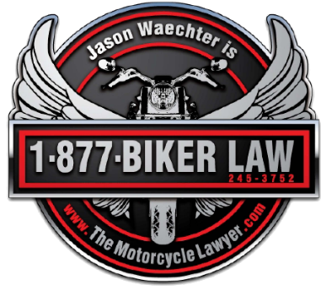
LINKS with More Info:
State of Michigan RiderCoach Requirements:
https://www.michigan.gov/sos/0,4670,7-127-1627_46351_46357---,00.html

State of Michigan RiderCoach Brochure:
https://www.michigan.gov/documents/sos/RiderCoach_Recruitement_Brochure_534177_7.pdf

State of Michigan Motorcyclist Training Site Locator:
https://www.michigan.gov/sos/0,4670,7-127-1627_46351_61092---,00.html

Michigan Rider Education Program
Michigan Department of State
430 West Allegan Street, 3rd Floor
Lansing, MI 48918
517-241-6850
motorcycling@michigan.gov
www.michigan.gov/mi-rep

Motorcycle Safety Foundation (MSF)
Great background on who teaches, the qualifications, what the course covers, and what you can expect here:
https://www.msf-usa.org/ridercoaches.aspx

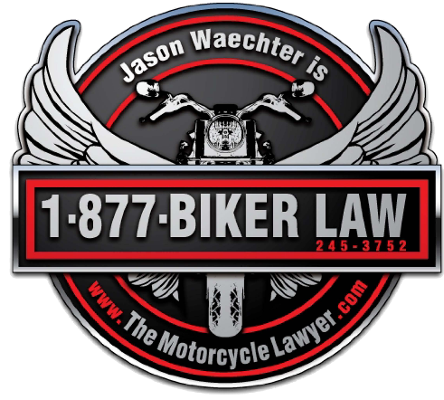
Really helpful info you won’t find anywhere but here:
In researching and gathering all the information needed, I realized all of this can be a little confusing. Therefore, here are three people in the know who can be contacted with specific questions and can explain it all in full detail:

Motorcycle Class Contact at Macomb Community College
motorcycle@macomb.edu
Renee Waraksa
Phone: (586) 498-4112

Karen Woolman
Phone: (586) 498-4156

Schoolcraft College
Motorcycle Safety call: 734-462-4594

For Private Sponsor - Wolverine Harley Davidson
David Friedel
586-464-1350
Dfriedel@wolverinehd.com

